Project Design Phase–II
Data Flow Diagrams & User Stories
Date | 04 August 2026
Team Id
Project Name | Automated Network Request Management in ServiceNow
Maximum Marks | 4 Marks
Data Flow Diagram :
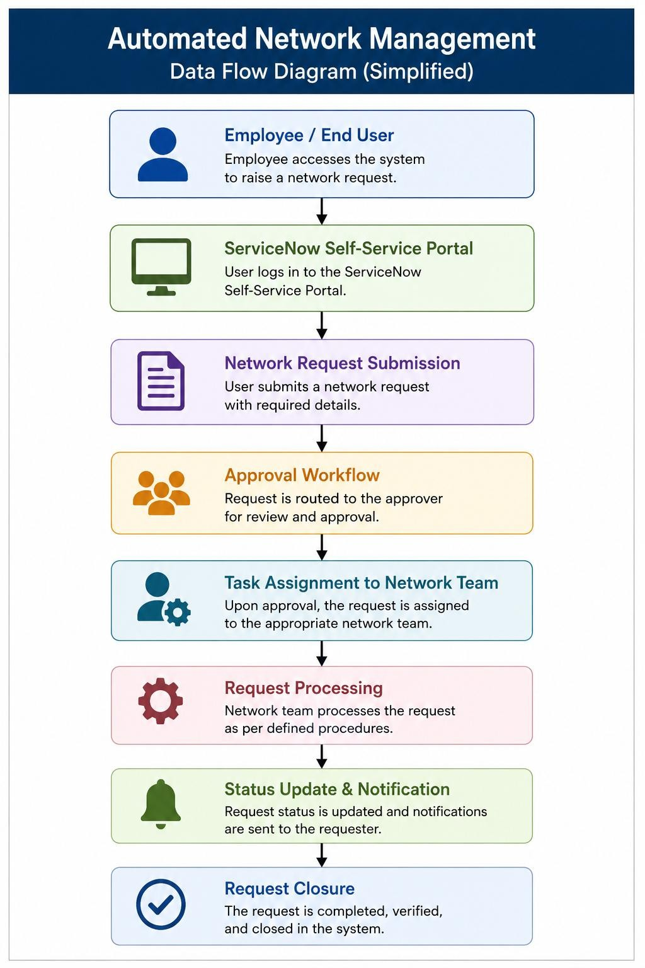

User Stories

User Type | Functional Requirement  (Epic) | User Story  Number | User Story / Task | Acceptance Criteria | Priority | Release
Employee | Request Submission | USN–1 | As a user, I can submit a network request through the  Service Portal | Request is created successfully | High | Sprint–1
Employee | Request Tracking | USN–2 | As a user, I can view request status | Status updates are  visible | High | Sprint–1
Employee | Notifications | USN–3 | As a user, I receive email notifications for request updates | Notifications are delivered | Medium | Sprint–1
Approver | Request Approval | USN–4 | As an approver, I can approve or reject requests | Approval updates request  status | High | Sprint–2
Network Admin | Task Management | USN–5 | As a network administrator, I can receive and process  assigned tasks | Task assignment works  correctly | High | Sprint–2
Administrator | Reporting | USN–6 | As an admin, I can monitor requests through dashboards | Reports display request  details | Medium | Sprint–3

